Project System Requirements & Architecture Specification
Subscription-Based Cloud Kitchen Meal Delivery Platform (Dinely)
Name- Kshirabdi Tanaya Mishra
College of engineering Bhubaneswar

1. System Overview & Problem Statement
Problem Statement
Many urban professionals, students, fitness enthusiasts, and busy families struggle to maintain a healthy, consistent, and affordable daily diet. Existing traditional food delivery aggregators (like Swiggy or Zomato) primarily focus on on-demand restaurant orders. This leads to several issues: high dynamic pricing, high delivery charges per meal, unpredictable preparation times, and a lack of structured daily nutritional planning.
Moreover, traditional restaurants prioritize dynamic dine-in and broad menus over repetitive, high-efficiency batch meal prep. Without a dedicated subscription-based delivery model powered by specialized cloud kitchens, customers face financial strain and nutritional inconsistency when ordering daily food online. A dedicated Subscription-Based Cloud Kitchen Meal Delivery System is required to offer scheduled, personalized, cost-effective, and recurring meal solutions directly to consumers.
Underlying Factors
- High Cost of On-Demand Food Ordering: Standard food delivery platforms charge significant delivery fees, dynamic surge pricing, and packaging fees per single order.
- Dietary & Health Gaps: Restaurant menus change, and standard delivery services lack multi-week customized dietary plan tracking (e.g., keto, high-protein, calorie-deficit, diabetic-friendly).
- Operational Bottlenecks: Dine-in restaurants struggle to handle simultaneous on-demand peak lunch/dinner rushes alongside recurring scheduled deliveries.
- Wastage & Sourcing Issues: Traditional food businesses struggle with inventory waste, whereas cloud kitchens operating on subscription models know exact meal counts in advance.
2. Stakeholders & Expected Users
Internal Stakeholders
- Platform Administrator: Manages system settings, subscription tiers, user roles, payment gateways, platform analytics, and dispute resolutions.
- Cloud Kitchen Operations Manager: Oversees kitchen operations, meal prep schedules, raw material inventory, batch processing, and dispatch packaging.
- Dietitians & Nutritionists: Creates curated meal plans, calculates macronutrients (calories, proteins, carbs, fats), and provides nutritional consultations.
- Kitchen Staff / Chefs: Handles kitchen prep, cooking, packaging quality checks, and kitchen safety compliance.
- Delivery Partners (Fleet): Executes optimized delivery routes for scheduled meal drops (morning, lunch, dinner).
- Technical & IT Support: Maintains backend infrastructure, Cloud Kitchen Order Management System (KOMS), routing engines, and mobile applications.
External Users & Target Audience
- Subscribers / Consumers: Daily consumers who subscribe to weekly/monthly meal plans (e.g., office workers, gym-goers, elderly individuals, college students).
- Ingredient Suppliers: Third-party raw material suppliers, eco-friendly packaging providers, and local farm collectives.
- Corporate & Institutional Clients: Corporate offices purchasing bulk meal subscriptions for staff daily lunches.
3. System Objectives & Expected Outputs
Key Objectives
- Provide automated, highly customizable subscription meal plans (Weekly, Monthly, Bi-weekly) with scheduled delivery time slots.
- Eliminate restaurant dine-in overhead by utilizing hyper-efficient centralized and hub-and-spoke Cloud Kitchens.
- Offer personalized nutrition planning through AI recommendations and certified Dietitian consultations.
- Optimize kitchen prep workflows by leveraging deterministic subscription counts to minimize food waste to < 2%.
- Ensure seamless recurring billing, auto-renewals, subscription pauses, meal skips, and flexible address modifications.
Expected Outputs
- Personalized Meal Dashboard showing upcoming daily meals, macro breakdowns, and delivery status.
- Dynamic Delivery Route Manifests generated daily for fleet drivers based on localized cluster delivery slots.
- Automated Kitchen KDS (Kitchen Display System) showing exact batch prep quantities per shift.
- Nutritional and Caloric Analysis Reports downloadable for subscribers.
- Inventory Forecast Reports for raw material procurement.
4. Strategic, Tactical & Operational Information
- Strategic Focus: Expand hub-and-spoke cloud kitchen footprint; maximize customer lifetime value (LTV) via recurring revenue; promote eco-friendly packaging and zero-waste food systems.
- Tactical Execution: Optimize batch prep schedules; analyze customer retention rates; refine dietitian-curated menus based on customer ratings; manage fleet efficiency per delivery zone.
- Operational Activities: Real-time order dispatching; daily ingredient stock logging; automated meal skip/pause processing before nightly cut-off times; fleet tracking.
5. Feasibility Study
Feasibility Aspect | Detailed Evaluation
Technical Feasibility | High feasibility using scalable cloud architectures (Node.js/Python microservices, React Native mobile apps, PostgreSQL, Redis caching, and Google Maps API for cluster routing). Integration with Razorpay/Stripe for recurring billing.
Economic Feasibility | Strong ROI model. Cloud kitchens reduce operational overheads by 60% compared to traditional dine-in restaurants. Predictable subscription revenue stabilizes cash flow and minimizes food waste loss.
Operational Feasibility | Highly feasible. Operating on strict cut-off times (e.g., pause/change meals by 10 PM for next-day delivery) allows kitchens to batch-prep orders with max efficiency.
6. System Requirements
Functional Requirements
- User Authentication & Profile Management (Dietary preferences, allergies, delivery addresses).
- Subscription Engine (Weekly/Monthly plan selection, meal customization, pause/resume/cancel features).
- Cloud Kitchen Management & KDS (Batch order queue, prep checklists, dispatch tagging).
- Dietitian & AI Recommendation Module (Macro calculation, tailored meal plans).
- Delivery Route Optimization Engine (Cluster-based delivery batching for drivers).
- Payment Gateway Integration (Automated recurring subscription billing, wallets, UPI auto-pay).
- Real-time Order & Delivery Tracking.
Non-Functional Requirements
- High Availability & Scalability (99.9% uptime with cloud autoscaling during peak prep hours).
- Performance (API latency < 200ms, route optimization computation < 5s).
- Security & Compliance (PCI-DSS compliance for payment processing, GDPR/Data Privacy for health metrics).
- User Experience (Intuitive UI for 3-click meal plan customizations).
7. Data Science & Analytics Activities
- Descriptive Analytics: Subscription retention rates, top-rated meals, daily active deliveries, macro consumption trends per demographic.
- Diagnostic Analytics: Root-cause analysis of churn rates, late delivery reasons in specific geographical clusters, meal skip patterns.
- Predictive Analytics: AI-driven demand forecasting for ingredient procurement based on seasonal trends and active subscriptions.
- Prescriptive Analytics: Automated dynamic menu recommendations based on user nutritional targets and real-time inventory levels.
8. System Architecture & Diagrams
This section presents complete graphical UML diagrams representing Use Cases, Activity Workflows, Sequence Diagrams, Database Schemas, and System Collaboration.
8.1 System Use Case Diagram
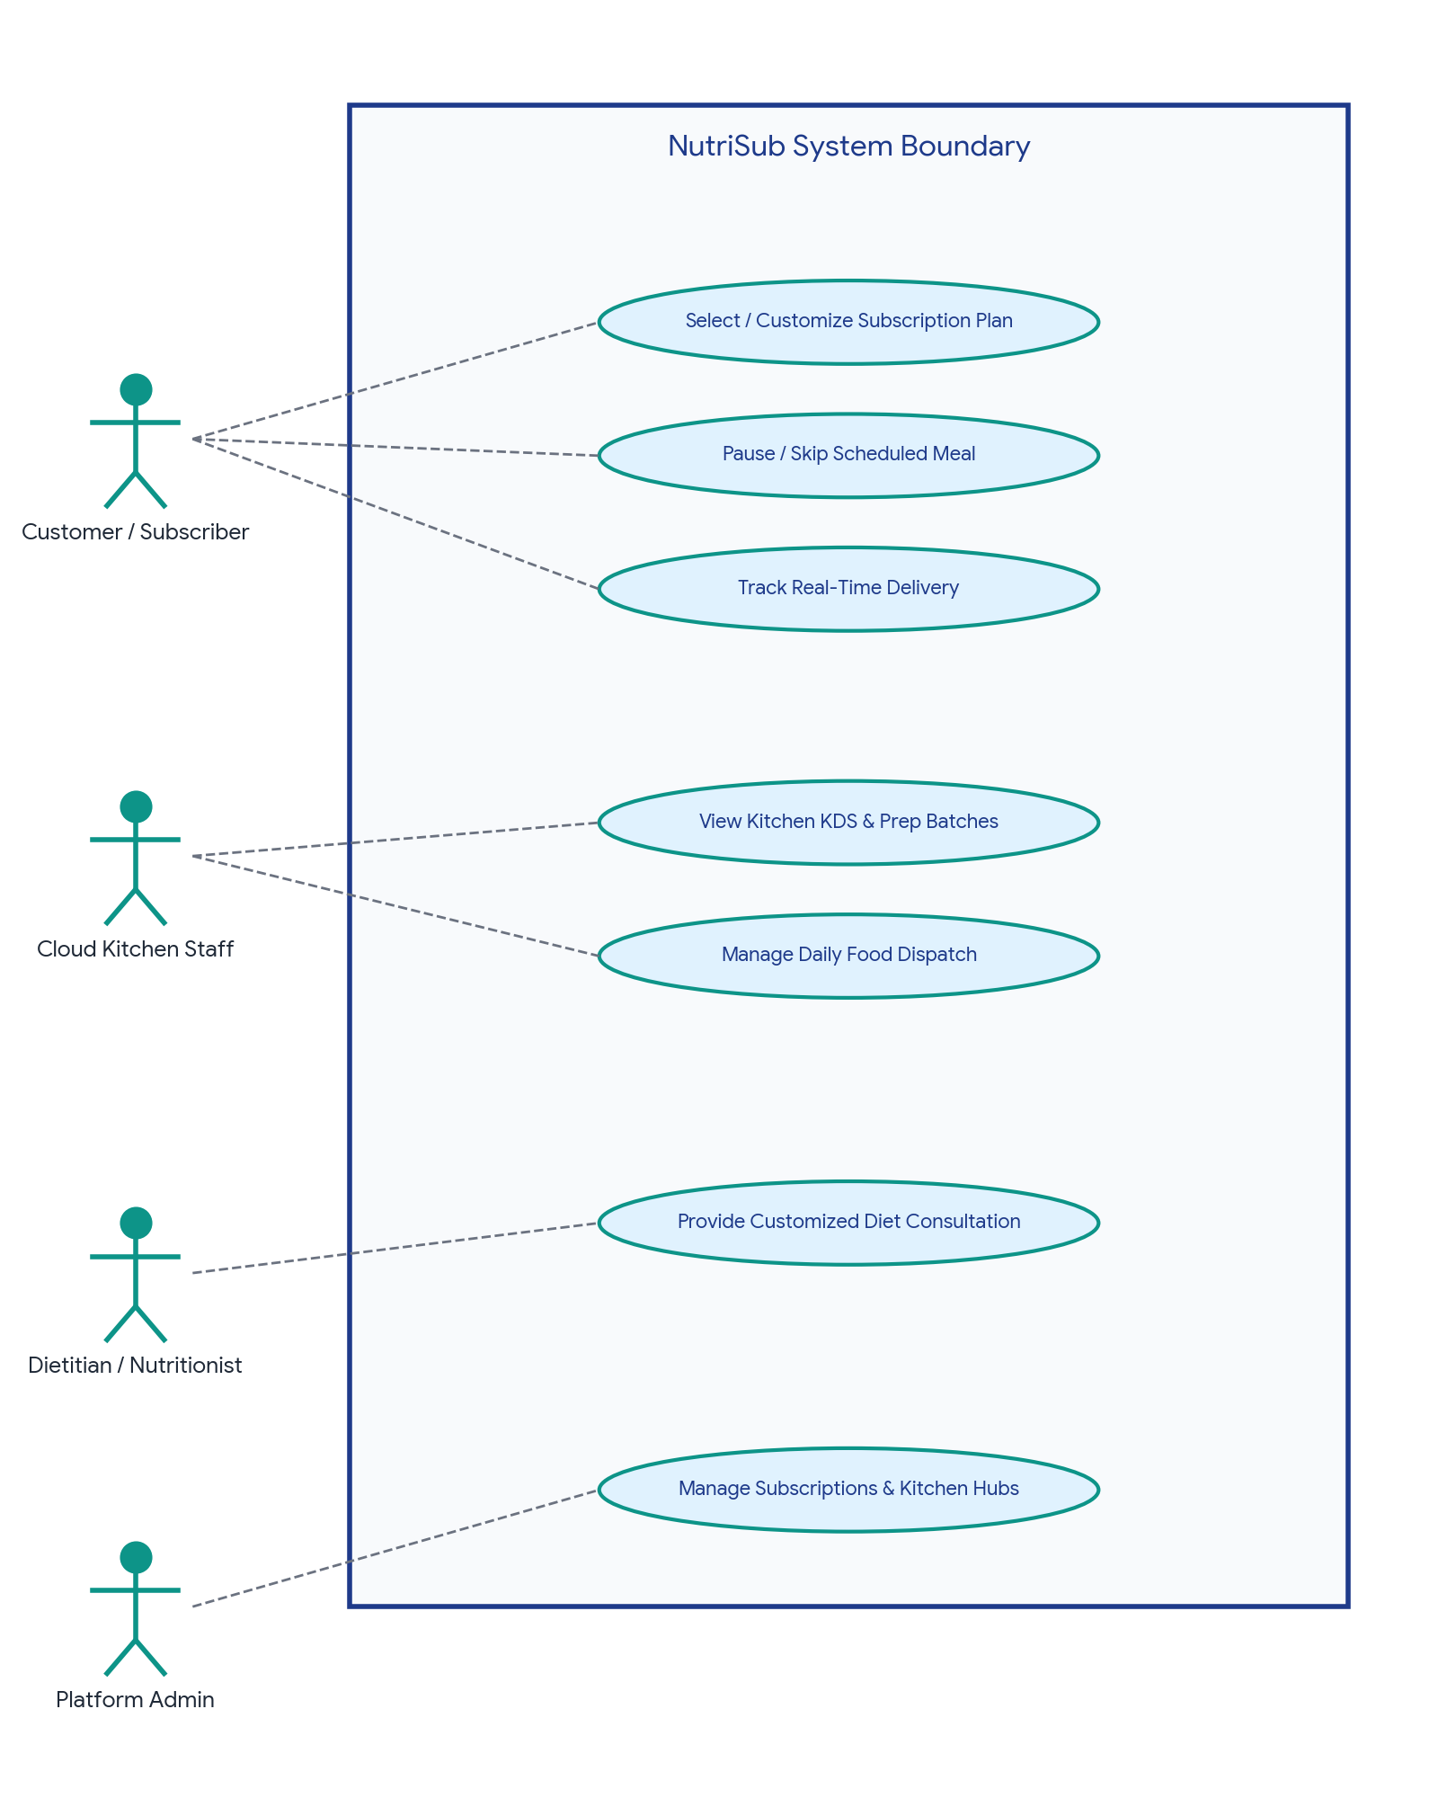
8.2 Customer Activity Workflow Diagram
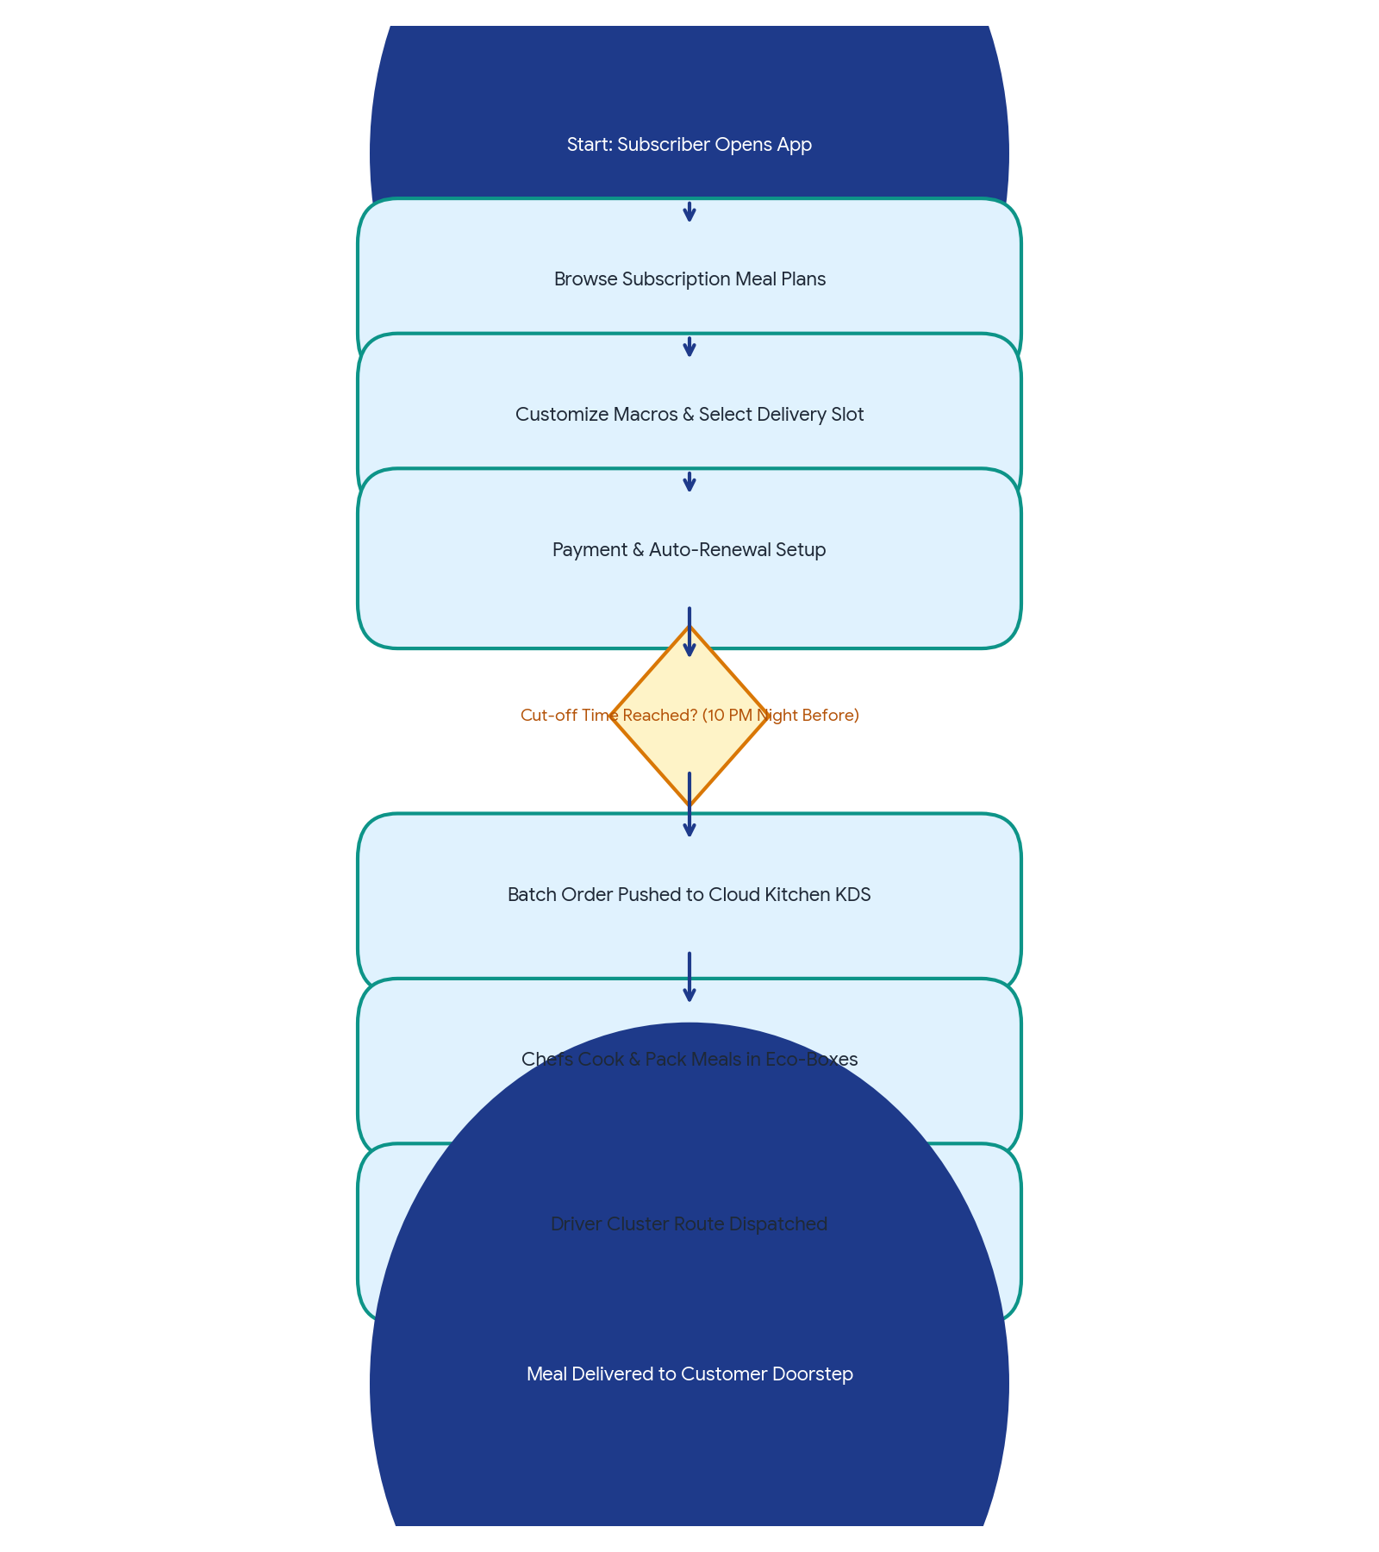
8.3 Subscription Fulfillment Sequence Diagram
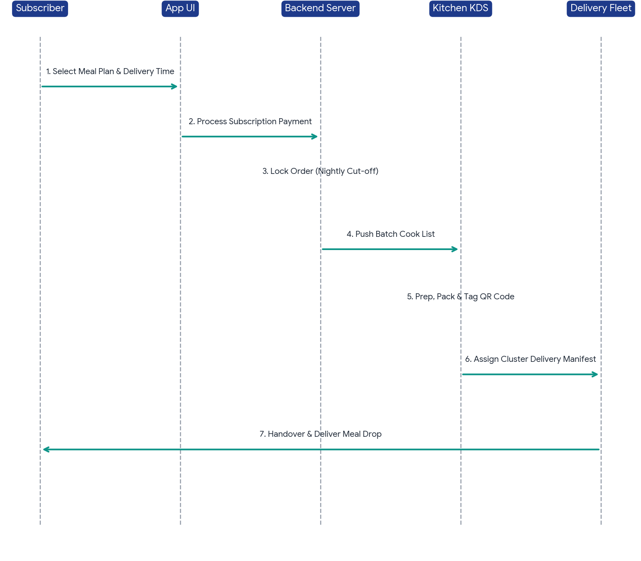
8.4 Database Schema & Entity Relationship Model
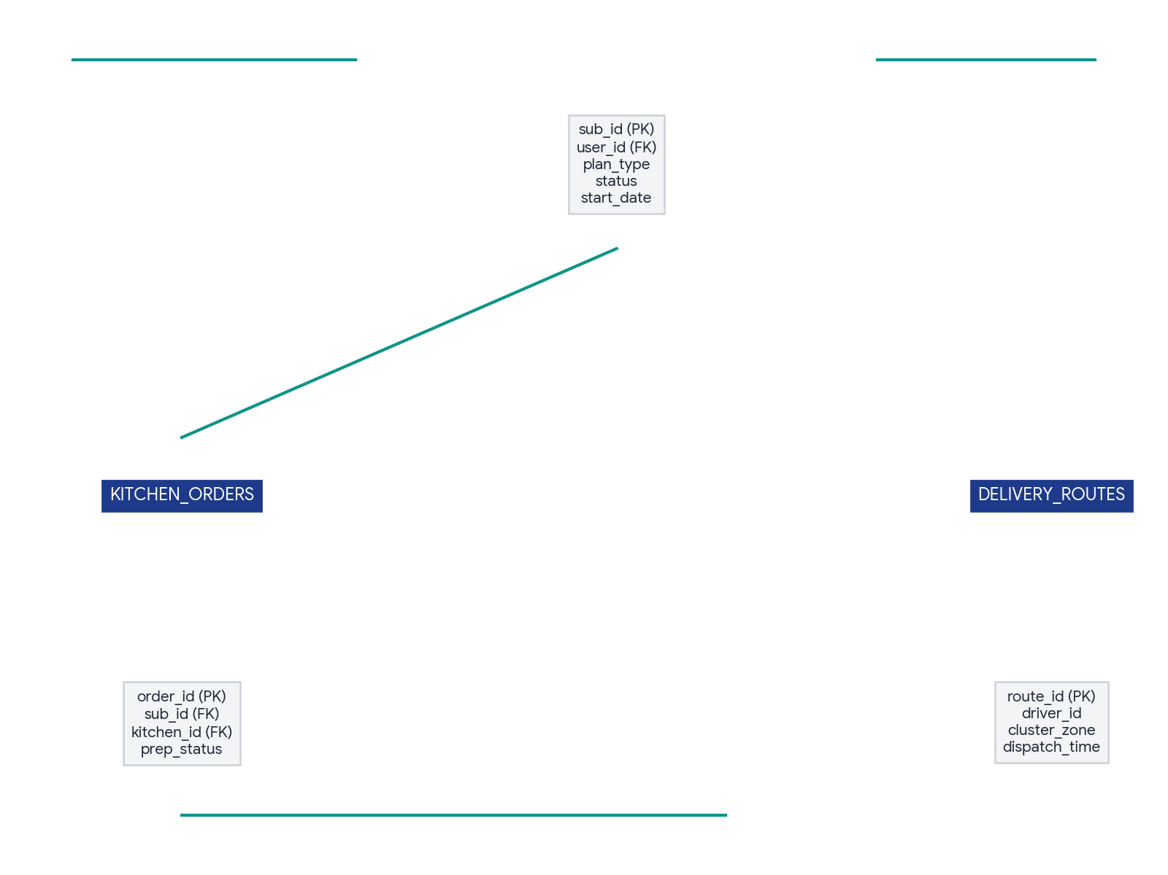
9. Ethical, Regulatory & Safety Measures
- Food Safety & Allergen Transparency: Full disclosure of all ingredients, allergen alerts (nuts, dairy, gluten), and accurate macronutrient calculations certified by registered dietitians.
- Regulatory Compliance: Strict adherence to FSSAI / local food authority hygiene standards across all cloud kitchen hubs with daily digital temperature logs.
- Data Privacy: Secure storage of subscriber dietary and health profile metrics using AES-256 encryption.
- Environmental Sustainability: Use of 100% biodegradable or recyclable meal containers and optimized delivery route planning to reduce overall carbon footprint.

